PART NINE B:
EAR TRAINING/THEORY

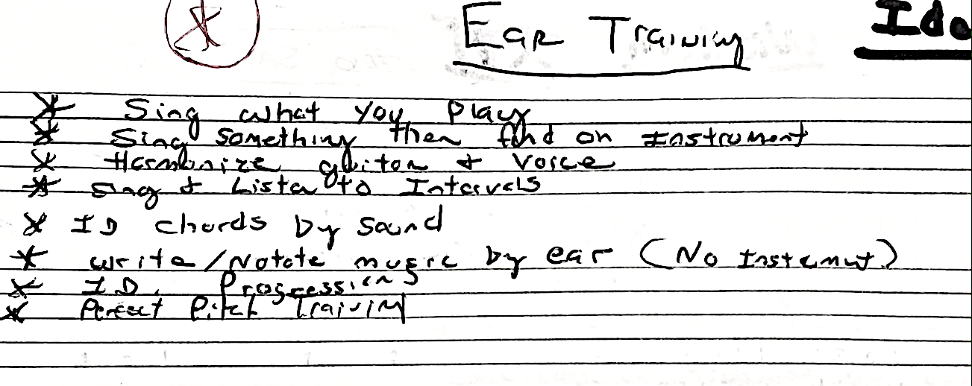

THEORY/READING

THE MODES OF THE MAJOR SCALE
NAME ALTERED DEGREES PATTERNS USED
G Ionian/Major None (113322)
A Dorian “b3, b7” (211133)
B Phrygian “b2, b3, b6, b7” (332111)
C Lydian “#4” (133231)
D Mixolydian/Dom ”b7” (111331)
E Aeolian/Natural “b3, b6, b7” (221113)
F# Locrian “b2, b3, b5, b6, b7” (332211)
There’s always a shift on the second string.
Memorize these modes forwards and backwards starting on any note.

- “The Mother of them all The Major Scale” (On One String)
- Play it on one string (any finger) starting on any root note.
- Play it on one string starting on 3rd or 5th any root.
- Pick one of the modes below and practice one a day focusing on the highlighted ones.
- Learn the modes:
- Ionian: WWHWWWH (Mom)
- Dorian: WHWWWHW (Jazz)
- Phrygian: HWWWHWW (Neoclassical)
- Lydian: WWWHWWH (#4)
- Mixolydian: WWHWWHW (Dominant b7th)
- Aeolian: WHWWHWW (Natural Minor)
- Locrian: HWWHWWW (Half Diminished)

Don’t worry be happy, it’s all the same just starting on a different note. A Few More (As if those weren’t enough):
- Pentatonic: minor 3rd, W, W, minor 3rd, W (important)
- Melodic minor: WHWWWWH (major scale with m3rd, Jazz)
- Harmonic Minor: WHWWHW, M3rd (Neoclassical)
- Whole tone: WWWWWW (Augmented)
- Half/Whole: HWHWHW (Dim)
- Whole/Half: WHWHWH (Dim)
- Blues: M3, W,H,H, M3,W
