PART ONE:
CHROMATIC (FOUR NOTES PER STRING) WARMUPS
Ways to practice:
- Use any of the patterns and loop it: Be able to continuously repeat it.
- Alternate picking: Starting on a Down then an Up (D U) or starting on an up stroke (U D).
- Chromatically: Moving up or down on one string.
- Vertically: Moving across the strings (Top to Bottom 6-1 or Bottom to top 1-6).

Chromatic Fingerings - Numbers represent left hand fingers. (PICK A FEW EACH DAY YOU PRATICE).


Staggered Chromatics - Do on any two adjacent strings. (WEEKLY)
E|--------------------------
B|--------------------------
G|--------------------------
D|--------------------------
A|-----3-----4-----1-----2--
E|--1-----2-----3-----4-----

E|--4-----3-----2-----1-----
B|-----2-----1-----4-----3--
G|--------------------------
D|--------------------------
A|--------------------------
E|--------------------------

STRETCHING EXERCISE - (WEEKLY)
- Stretching space between fingers 1 & 2
- 12-14-15-16
- Stretching space between fingers 2 & 3
- 12-13-15-16
- Stretching space between fingers 3 & 4
- 12-13-14-16
- Stretching space between all fingers
- 12-14-16-18
- Diagonal stretching (this example is stretching between fingers 1 & 2, but you get the idea)

E-12-------------
b----14----------
g-------15-------
d----------16----

BONUS EXERCISES (FOR THE HIGH ACHIEVERS OUT THERE!)

Adding A Chromatic Note - (AS NEEDED)

---1-2-1-2-3-2-1-2-3-4-3-2-1-------4-3-4-3-2-4-3-2-1-2-3-4--------

Fingers 1,2,3,4 on same fret - Ascending, Descending & Vertical (AS NEEDED)
For Example, play note C (3rd string/3rd fret) using 1st finger then 2nd finger etc. as quickly as cleanly possible.

Warm-Ups Without A Guitar
MASSAGES/STRETCHES (AS NEEDED)
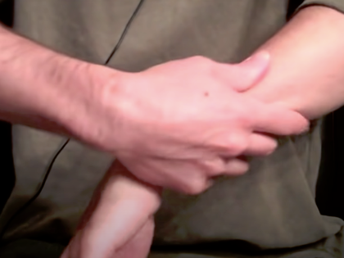
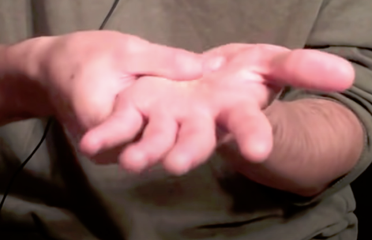
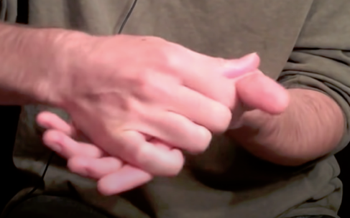

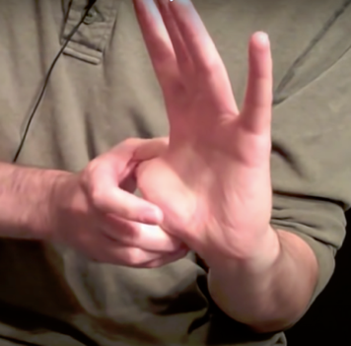
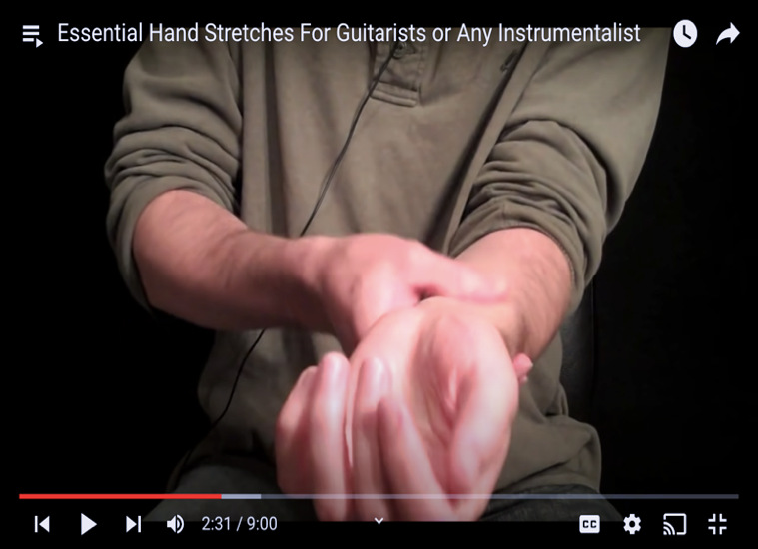
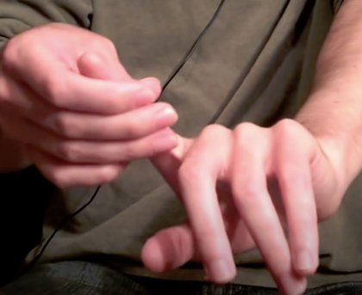

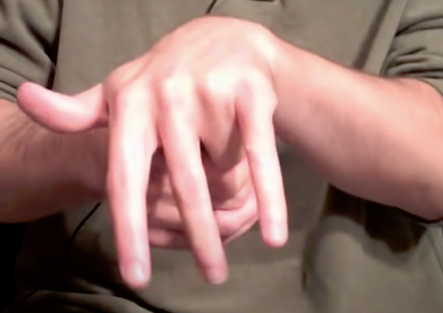
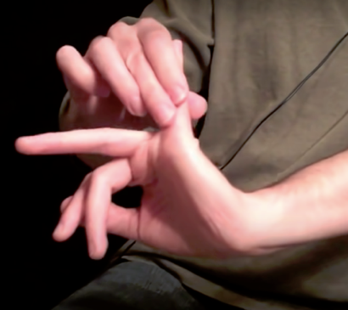
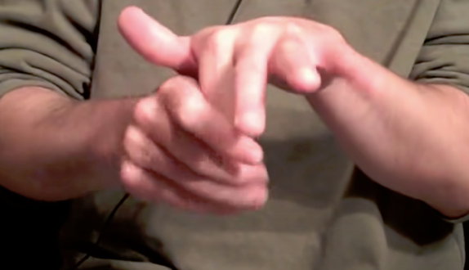

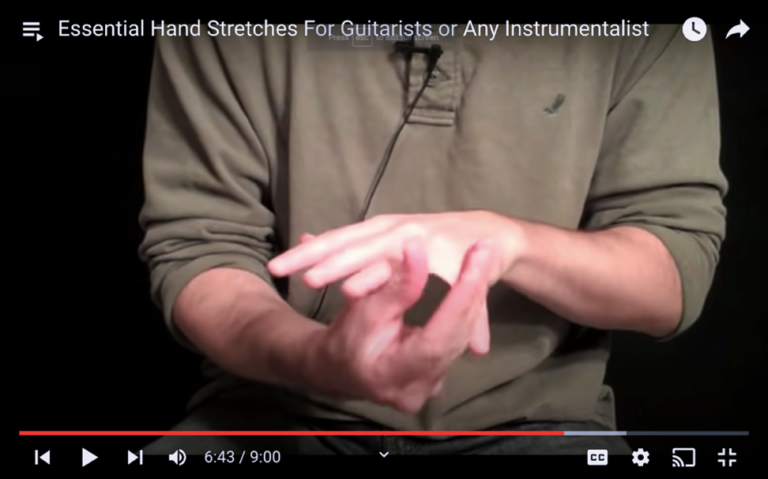
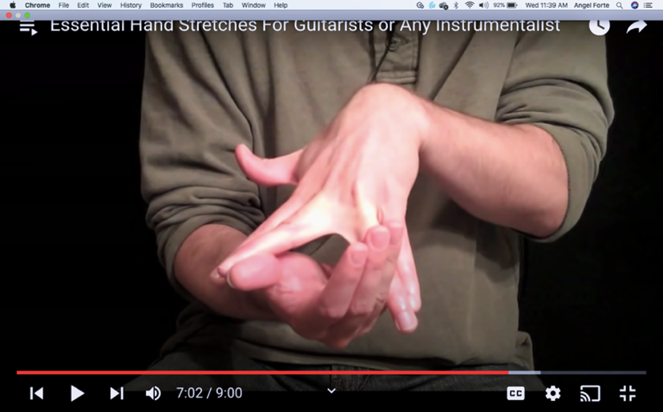

THE SPIDER (OFF AND ON THE GUITAR)
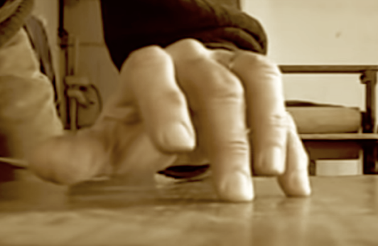
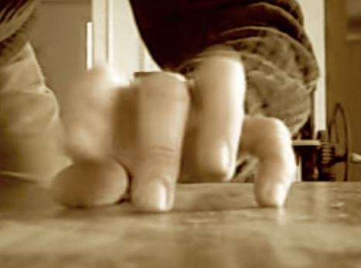
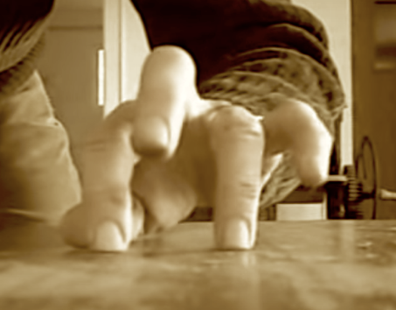

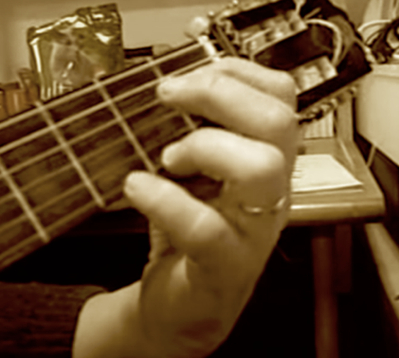
THE SPIDER (ON THE GUITAR)

